**Sequence Diagram – Nativ Kolisher**

**Ex 1 – start and end communication**

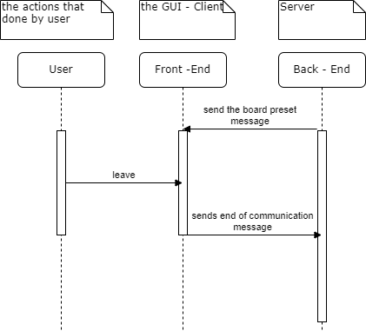

**Ex 2 – Moving piece on board**

